**VISVESVARAYA TECHNOLOGICAL UNIVERSITY**

**BELAGAVI, KARNATAKA, INDIA**



Seminar On

**DESIGN FOR 4D-PRINTING: THE DESIGN SPACE AROUND SMART MATERIALS**

by

**DEEPAK S L**

**(USN:1GA15ME022)**



Under the guidance of

**Vijaykumar Pujar**

Assistant Professor

Department of Mechanical Engineering

Global Academy of Technology, Bengaluru, Karnataka, India

**2018 - 19**

**GLOBAL ACADEMY OF TECHNOLOGY**

Ideal Homes Township, Mysore Road, Raja Rajeshwari Nagar, Bengaluru-560098



**DEPARTMENT OF MECHANICAL ENGINEERING**

***CERTIFICATE***

“**Design by Analyses of Cylindrical Pressure Vessels With Tori-Spherical End Closures”** has been successfully presented by STUDENT NAME (1GA10MMN01) a student of VIII semester B.E. for the partial fulfillment of the requirements for the Bachelor’s degree in Mechanical Engineering of the VISVESVARAYA TECHNOLOGICAL UNIVERSITY during the academic year 2017-18.

**Guide HOD**

**Bharat V** **Dr. T. Krishna Rao**

Associate Professor Professor& Head

Department of ME Department of ME

Global Academy of Technology Global Academy of Technology

Bengaluru Bengaluru

**DEPARTMENT OF MECHANICAL ENGINEERING**

**GLOBAL ACADEMY OF TECHNOLOGY**

**Bengaluru**

**ACKNOWLEDGEMENT**

The satisfaction that accompany the successful completion of any task would be incomplete without the mention of the people who made it possible, whose constant guidance and encouragement crowned the efforts with success.

I would like to express my thanks to the Principal **Dr. N. Rana Pratap Reddy** for their encouragement that motivated me for the successful completion of Seminar work.

It gives me immense pleasure to thank **Dr. T. Krishna Rao,** Professor and Head of Department for his constant support and encouragement.

Also, I would like to express my deepest sense of gratitude to my Seminar mentor **Mr. Bharat V.**, Associate Professor, Department of Mechanical Engineering for his constant support and guidance throughout the Seminar work.

Gurusharan

USN: 1GA10MMN01

# ABSTRACT

Cylinders with Tori-spherical end closures are used as pressure vessels and cylindrical containers in aerospace, thermal and nuclear industries. Structural Integrity of the Pressure vessel is an important aspect of design process. Critical stress analysis to locate the possible failure locations, prediction of critical buckling loads to avoid failure due to buckling and Fracture Mechanics Analysis of the cylinder with tori-spherical end closure is the main focus of this study.

This report presents the refined Finite Element Model development of a for the prediction of possible failure locations by stress analysis, critical buckling loads and prediction of stress intensity factors for a cylinder with tori-spherical end closure having an axial and a circumferential crack subjected to internal pressure. A special purpose post processing sub-program 3MBSIF is used for the prediction of Membrane and Bending Stress Intensity Factors.

The proposed Finite Element Model is implemented using ANSYS. Static Analysis module is invoked to calculate von-Mises Stress Contours. Eigen-Buckling module is invoked to predict critical buckling loads and Post-processing subprogram 3MBSIF is used to compute the Stress Intensity Factors. The methodology is validated using benchmarks, a set of standard test problems with known target solutions.

Parametric studies are carried out to quantify the effect of crack location, orientation, and length on the Stress Intensity Factors. Significant numerical results are presented and discussed.

# LIST OF FIGURES

|  |  |  |
| --- | --- | --- |
| Figure 1.1 | Different types of heads for pressure vessels | 1 |
| Figure 1.2 | (a) Circumferential stress (b) Longitudinal stress and (c) Radial stress developed in thin cylinders | 2 |
| Figure 1.3 | Circumferential and Longitudinal stresses in thin cylinder | 3 |
| Figure 4.1 | FE Model of 3D tori spherical head | 8 |
| Figure 4.2 | FE Model of cylindrical shell with axial crack | 9 |
| Figure 4.3 | FE Model of cylindrical shell with circumferential crack | 9 |
| Figure 5.1 | Meridional and Hoop stress distribution in the cylindrical pressure vessel with tori spherical end closure for R/t=100 | 10 |
| Figure 5.2 | Stress distribution in a cylindrical pressure vessel with tori spherical end closure (R/t=20) | 10 |
| Figure 5.7 (a), (b) | Buckled shape of the vessel for $\frac{R}{t}=20$ | 11 |
| Figure 5.8 | Influence of thickness on buckling pressure for various knuckle radii | 12 |
| Figure 5.9 | Influence of knuckle radius on buckling pressure for various thickness | 12 |
| Figure 6.1 | von Mises stresses for case study 1, β=1 | 13 |
| Figure 6.2 | von Mises stresses around crack tip for case study 1, β=1 | 13 |
| Figure 6.3 | Displacement plots for case study 1, β=1 | 14 |
| Figure 6.4 | Normalized mode I membrane SIF (present analysis) – Case Study 1 | 14 |
| Figure 6.5 | Normalized mode I bending SIF (present analysis) – Case Study 1 | 15 |
| Figure 6.6 | Normalized mode II membrane SIF (present analysis) – Case Study 1 | 15 |
| Figure 6.7 | Normalized mode II bending SIF (present analysis) – Case Study 1 | 15 |
| Figure 6.8 | von Mises stresses for case study 2, β=1 | 16 |
| Figure 6.9 | von Mises stresses around crack tip for case study 2, β=1 | 17 |
| Figure 6.10 | Displacement plots for case study 2, β=1 | 17 |
| Figure 6.11 | Normalized mode I membrane SIF (present analysis) – Case Study 2 | 18 |
| Figure 6.12 | Normalized mode Ibending SIF (present analysis) – Case Study 2 | 18 |
| Figure 6.13 | Normalized mode IImembrane SIF (present analysis) – Case Study 2 | 18 |
| Figure 6.14 | Normalized mode II bending SIF (present analysis) – Case Study 2 | 19 |

ABSTRACT i

LIST OF FIGURES ii

CHAPTER 1 1

**INTRODUCTION** 1

**1.1 Pressure Vessel Design Philosophy** 1

CHAPTER 2 2

**LITERATURE REVIEW** 2

CHAPTER 3 3

**PROBLEM STATEMENT& METHODOLOGY** 3

**3.1 Objectives of the Proposed Work** 3

CHAPTER 4 4

**FINITE ELEMENT MODEL DEVELOPMENT** 4

**4.1 Axisymmetric Pressure Vessel with Tori-spherical End Closures for Static Analysis** 4

CHAPTER 5 5

**CONCLUSIONS** 5

**5.1 Model 1: 2D Cylindrical Pressure Vessel with Tori-spherical End Closure for Static Analysis** 5

References 6

# CHAPTER 1

## **INTRODUCTION**

### **1.1 Pressure Vessel Design Philosophy**

Pressure vessels may be of any shape, but most commonly employed shapes are spherical,

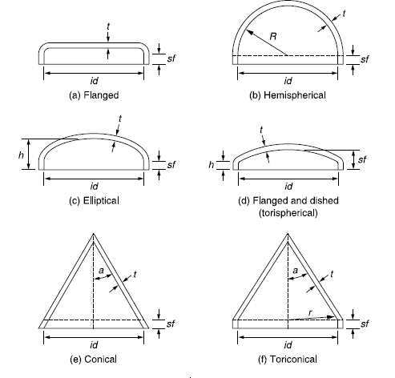

**Figure 1.1: Different types of heads for pressure vessels**

**1.2 Stresses in Thin Pressure Vessels**

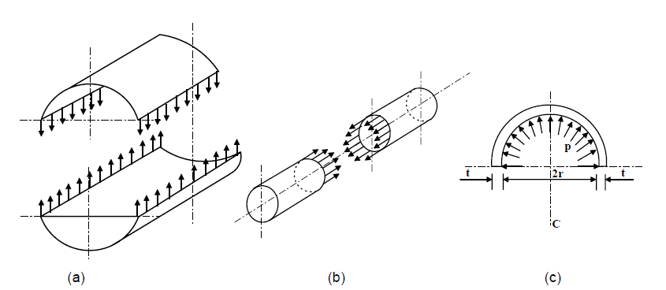

**Figure 1.2: (a) Circumferential stress (b) Longitudinal stress and (c) Radial stress developed in thin cylinders**

Thin pressure vessels are subjected to two types of stresses namely circumferential (hoop) stress which acts along the circumference of the cylinder and longitudinal stress which acts along the length of the cylinder.

Resisting force due to hoop stress in cylinder walls = $2×σ_{h}×L×t$

At equilibrium, $p×D×L=2×σ_{h}×L×t$

# CHAPTER 2

## **LITERATURE REVIEW**

**Jeevan T.P.** and **Divya H.V.** [1] performed 2D-static analysis by varying the thickness of pressure vessel to analyze the stresses and deflection due to internal pressure. They also performed Eigen value buckling analysis for different vessel thicknesses and knuckle radius to determine the critical buckling pressure. It was found that thickness of pressure vessel plays an important role to withstand the fluid pressure. By comparing the variation of buckling pressure, it was found that buckling pressure is more sensitive to thickness of the vessel compared to knuckle radius.

According to **E.O.Bergman** [2] pressure vessel codes give design methodology for simple cylindrical shells with standard type of openings under uniform pressure. Hence, the designer must apply engineering principles when dealing with complicated structures and loading systems. In his work “Design of Vertical Pressure Vessels Subjected to Applied Forces” he has discussed some design principles that are not covered in codes. It deals with vessels that are subjected to various forces along with internal or external pressure. Only cylindrical shells with vertical longitudinal axis are considered.

# CHAPTER 3

## **PROBLEM STATEMENT& METHODOLOGY**

### **3.1 Objectives of the Proposed Work**

1. To develop 2D axisymmetric and 3D Finite Element Model of tori spherical end closured cylindrical pressure vessel subjected to internal pressure.
2. This FE model is subjected to static, buckling and fracture analysis under suitable boundary conditions and loads.
3. From the results of static analysis, the variation of stresses in the pressure vessel in different regions will be plotted for various R/t ratios.

# CHAPTER 4

## **FINITE ELEMENT MODEL DEVELOPMENT**

### **4.1 Axisymmetric Pressure Vessel with Tori-spherical End Closures for Static Analysis**

Solids of revolution from 00 to 3600 are called as axisymmetric solids. In these problems we use cylindrical co-ordinates (r,θ,z).These structures are subjected to both axisymmetric loadings and

# CHAPTER 5

## **CONCLUSIONS**

### **5.1 Model 1: 2D Cylindrical Pressure Vessel with Tori-spherical End Closure for Static Analysis**

The static stress analysis of axisymmetric pressure vessel with tori spherical end closure

# References

1. Jeevan T.P., Divya H.V., “Finite Element Modeling for the Stress, Buckling and Modal Analysis of a Cylindrical Pressure Vessel with Tori-spherical Enclosure”, International Journal of Engineering Research & Technology,   Vol.2 - Issue 6, June – 2013.
2. E.O. Bergman, Alhambra, Calif, “The Design of Vertical Pressure Vessels Subjected to Applied Forces”, ASME Transactions, 1955, pp 576-580
3. C.K. Ramesh, TarunKanth, V.B. Jadhav. “Elastic Analysis of Pressure Vessels with Various End Closures” , International Journal of Pressure Vessel & Piping (2) 1974, pp 143-154
4. H.V.Lakshminarayana, M.V.V.Murthy, “On a Finite Element Model for the Analysis of Through Cracks in Laminated Anisotropic Cylindrical Shells”, Journal of Engineering Fracture Mechanics, Vol.14, No.4, pp, 1981, pp 697-712.
5. Shivashankar R. Srivatsa, H.V. Lakshminarayana, Pramod R., “Stress Intensity Factors for Arbitrarily Located and Oriented Cracks in a Cylindrical Shell with Tori-Spherical End Closures subjected to Internal Pressure”, International Journal of Engineering Research and Applications, Vol. 2, Issue 3, May-Jun 2012, pp.3057-3071.
6. M.V.V.Murthy, K.P.Rao, A.K.Rao, “On the Stress Problem of Large Elliptical Cutouts and Cracks in Circular Cylindrical Shells”, Int. Journal of Solid Structures, 1974, Vol.10, pp 1243-1269.